9.81: a)
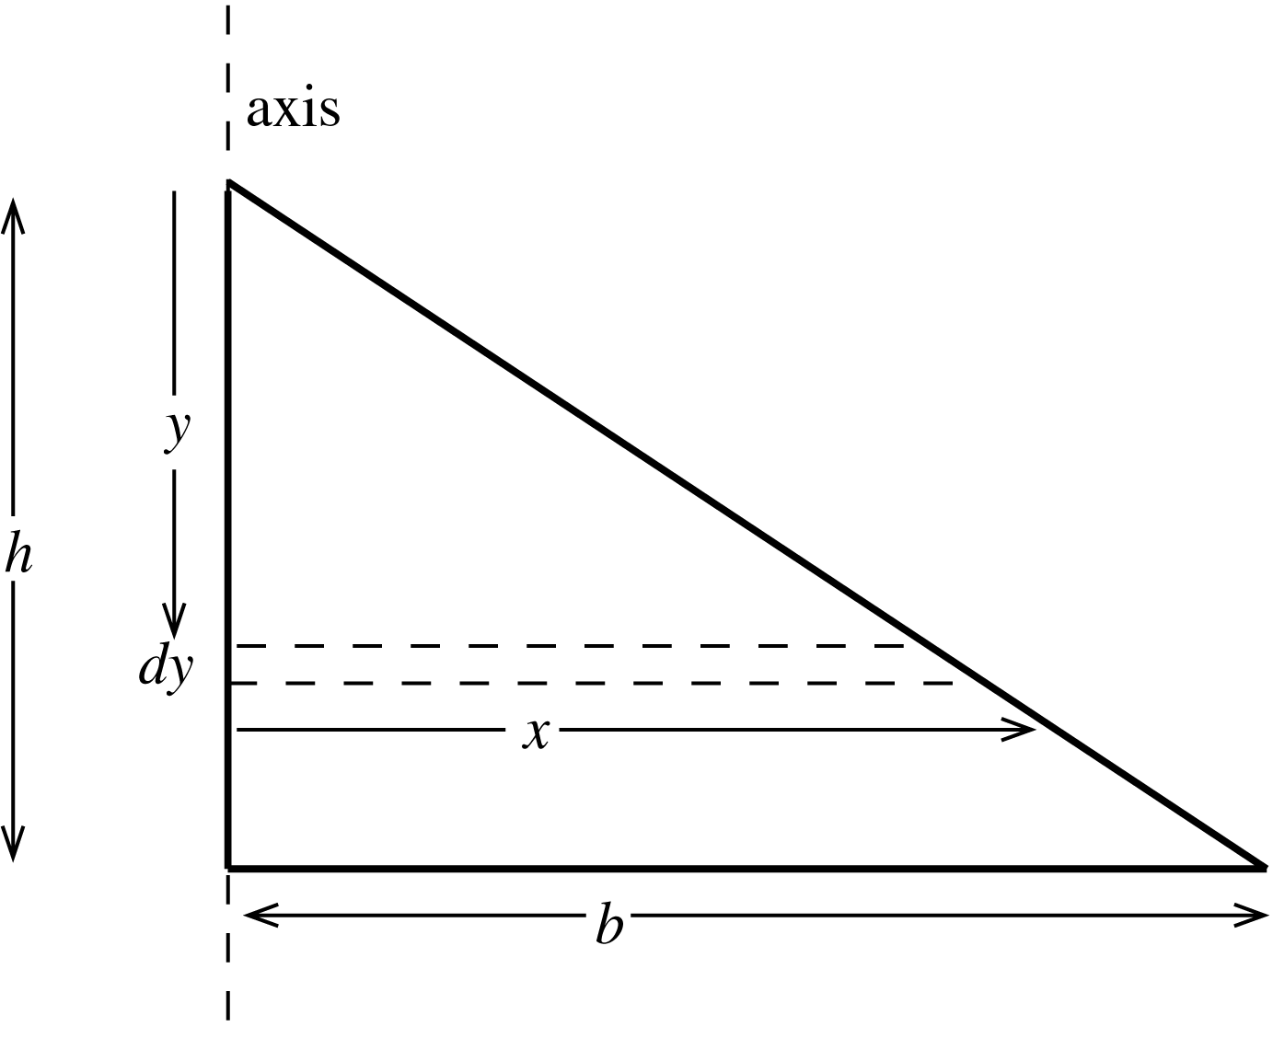

Consider a small strip of width dy and a distance below the top of the triangle. The length of the strip is 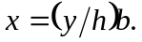
The strip has area x dy and the area of the sign is 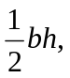 so the mass of the strip is
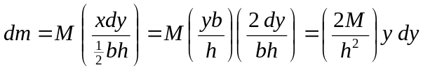
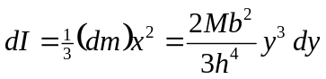
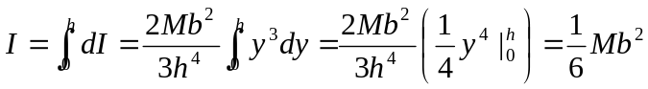
b) 